Email Registration

1. Open Visual Studio 2019
2. File –> New - > Project -> ASP.NET Web Application (.NET Framework) - >web forms

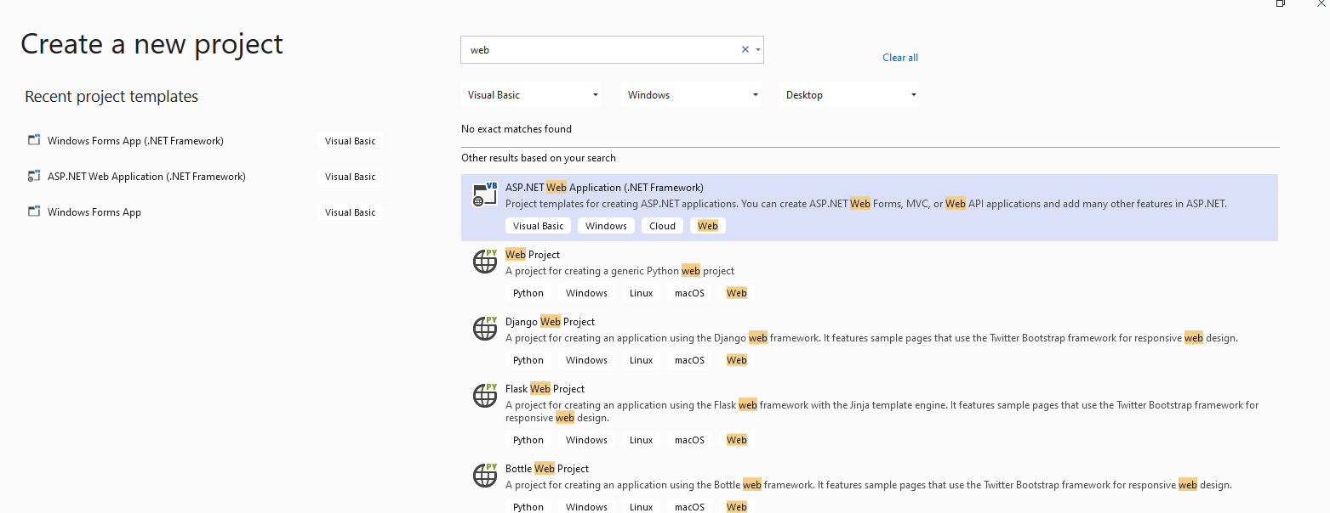

1. Project - > Add - > New Item -> Web Form -> Add

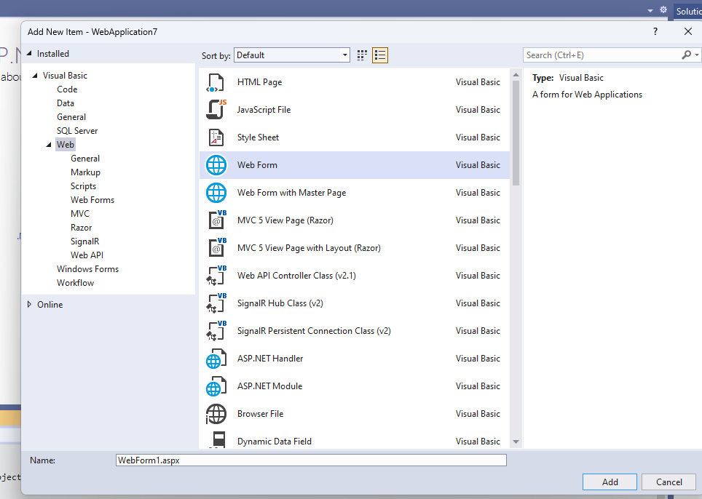

Select Source tab

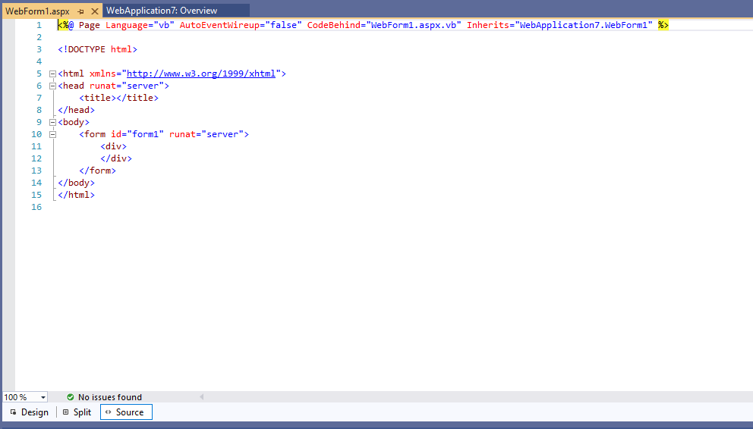

<%@ Page Language="VB" AutoEventWireup="false" CodeFile="emailregistration.aspx.vb" Inherits="emailregistration" %>

<!DOCTYPE html PUBLIC "-//W3C//DTD XHTML 1.0 Transitional//EN" "http://www.w3.org/TR/xhtml1/DTD/xhtml1-transitional.dtd">

<html xmlns="http://www.w3.org/1999/xhtml">

<head runat="server">

<title></title>

<style type="text/css">

.style1

{

text-align: center;

}

.style2

{

width: 178px;

}

.style3

{

width: 61px;

}

</style>

</head>

<body>

<form id="form2" runat="server">

<div>

</div>

<table style="width:100%;">

<tr>

<td class="style1" colspan="3">

EMAIL REGISTRATION FORM</td>

</tr>

<tr>

<td class="style2">

First Name</td>

<td class="style3">

<asp:TextBox ID="fname" runat="server" Width="183px"></asp:TextBox>

</td>

<td>

</td>

</tr>

<tr>

<td class="style2">

Last name</td>

<td class="style3">

<asp:TextBox ID="lname" runat="server" Width="183px"></asp:TextBox>

</td>

<td>

</td>

</tr>

<tr>

<td class="style2">

Address</td>

<td class="style3">

<asp:TextBox ID="address" runat="server" Width="183px"></asp:TextBox>

</td>

<td>

</td>

</tr>

<tr>

<td class="style2">

City</td>

<td class="style3">

<asp:TextBox ID="city" runat="server" Width="183px"></asp:TextBox>

</td>

<td>

</td>

</tr>

<tr>

<td class="style2">

Email ID</td>

<td class="style3">

<asp:TextBox ID="email" runat="server" Width="183px"></asp:TextBox>

</td>

<td>

</td>

</tr>

<tr>

<td class="style2">

Password</td>

<td class="style3">

<asp:TextBox ID="pwd" runat="server" TextMode="Password" Width="183px"></asp:TextBox>

</td>

<td>

</td>

</tr>

<tr>

<td class="style2">

Repassword</td>

<td class="style3">

<asp:TextBox ID="repwd" runat="server" TextMode="Password" Width="183px"></asp:TextBox>

</td>

<td>

</td>

</tr>

<tr>

<td class="style2">

&nbsp;</td>

<td class="style3">

&nbsp;</td>

<td>

&nbsp;</td>

</tr>

<tr>

<td class="style2">

&nbsp;</td>

<td class="style3">

<asp:Button ID="Button1" runat="server" Text="SUBMIT" />

</td>

<td>

<asp:Label ID="Label1" runat="server"></asp:Label>

</td>

</tr>

</table>

</form>

</body>

</html>



* Select Design tab - > Double Click Button

Imports System.Data

Imports System.Configuration

Imports System.Data.SqlClient

Imports System.Web.Services.Description

Partial Class emailregistration

Inherits System.Web.UI.Page

Protected Sub Button1_Click(ByVal sender As Object, ByVal e As System.EventArgs) Handles Button1.Click

Label1.Text = "Registration Successful"

End Sub

End Class

Select webform1.aspx.vb

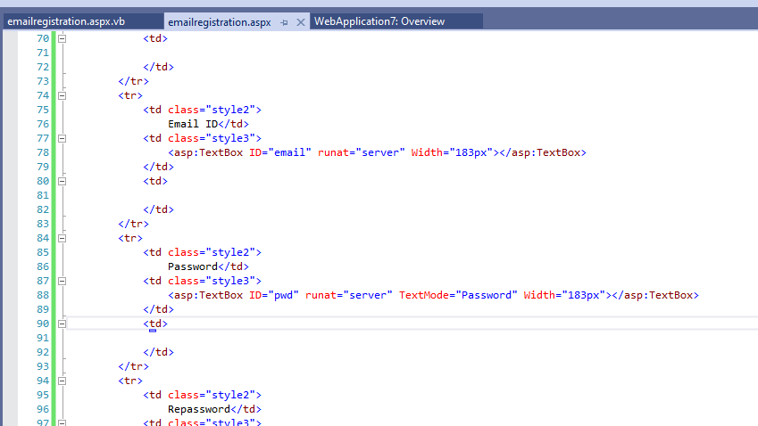

In Solution Explorer change File Name as emailregistration

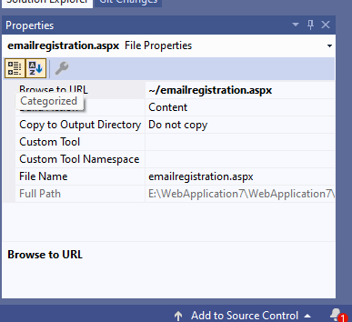

To Execute the program

Build -> Build Solution

Debug - > Start Debugging

